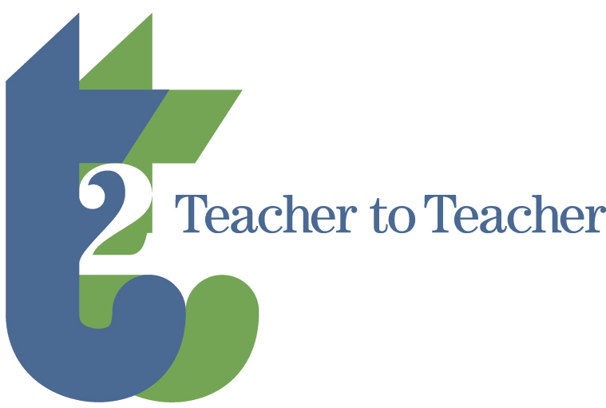
Teacher to Teacher
Teaching, Networking, Sharing,
Community-Building

A teaching event at the
Conference on College Composition and Communication
Chicago, IL

Saturday, March 12, 2022

Submission Deadline:
Friday, January 3, 2022

As writing teachers, we often as ourselves or answer our students question of “Why are we here?” As the 2022 call for proposals explains, this inquiry has multiple meanings. For this year’s Teacher to Teacher event, we want to know your best strategies, lessons, assignments, assessment practices, and activities that answer this question.

What do you do to give meaning to the writing class that you teach? What gives students a sense of purpose and worth when writing courses, especially first-year writing that are required classes? What do you do to get reluctant college students to engage with their own learning?

What do you do to ensure that all students have access?

In what ways is your class socially just both in construction and in practice? What do you DO in your course to make inclusion central and part of the fabric of every class meeting?

What do you do to reach each individual student who have varying levels of proficiency in writing and reading? What do you do for students who may not feel like they belong in your class, in college, or in higher education? How do the specific things in your teaching and classroom resist the gatekeeping qualities in higher education?

What do you do to create community in your classes? What gives students a sense of belonging and inclusivity.

Teacher to Teacher is in its fifth year as a staple of the Cs experience. Consider it a pedagogically-centered speed-dating event where you get a new group of colleagues after a segment of time.

You will engage others in conversation about how we answer the loaded question of “Why are we here?” Share your projects, ideas, and challenges in small groups with the goal of creating opportunities for conversation. The participants at your table will leave with concrete ideas, assignments, activities, and new ways to approach their teaching.

We welcome anyone invested in writing pedagogy (full-time, post-doc, part-time, graduate, undergraduate, and aspiring educators), and from any educational institution, a dedicated space to discuss teaching during the 2022 Convention. Literacy educators whether teaching in-person, through distance learning, mask-to-mask classes, and/or hybrid models are encouraged to share their best teaching strategies.

Possible Practice-based ideas and problems include, but are not limited to the following:
- Assignments: research-focused informal and formal writing projects, digital projects, blending narrative, rhetorical analysis
- Activities: group work, reading, in-class work, quick writes, shared writing, peer workshop
- Lesson Plans/or Teaching Concepts: on structure, scaffolding, academic synthesis, metadiscourse, logic, introductions, conclusions, genre conventions, argumentation
- Classroom Management: growing participation and engagement, record keeping, knowing your students, responding to essays and projects, and best practices in peer review.

We have so much to talk about this year and we want to know how you are managing in our new teaching landscape, and the dynamics of our 21st century classrooms.

T2T Goals:
- Share examples of effective writing projects (informal and formal)
- Consider new ways to address problems and challenges from the classroom
- Describe innovative writing pedagogies as solutions to situated problems
- Network with colleagues across institutional homes and programs
- Build community with similarly interested colleagues
- Bridge the divide between college and high school writing teachers
- Learn from innovative writing educators teaching a wide range of student populations and who represent diverse institutional settings.
- Consider professional and instructor development ideas and strategies for adjuncts and GTAs
- Offer support and coping strategies to help each other and our students

Registration: T2T is free to CCCC convention registrants, and those who are accepted and attend will be listed in the 2022 Convention program.

Submission Deadline: 11:59 p.m. EDT, Monday, January 3, 2022.
To submit a proposal, visit our Web site: https://sites.google.com/udel.edu/teacher2teacher/
Presentation acceptances will be announced on a rolling basis, but no later than January 21, 2022.

Notes: Presenters must register for the CCCC convention to present and have their names listed as a speaking role in the Convention book and on the T2T program.

Questions? Please feel encouraged to contact us: t2tatcccc@gmail.com
Christine Cucciarre (ccucc@udel.edu) and Lee Nickoson.

